Random Forest:

A random forest is a machine learning method for tackling classification and regression issues. It makes use of ensemble learning, a method for solving complicated issues by combining a number of classifiers.

In a random forest algorithm, there are many different decision trees. The random forest algorithm creates a "forest" that is trained via bagging or bootstrap aggregation. The accuracy of machine learning algorithms is increased by bagging, an ensemble meta-algorithm.

1.The Random Forest Algorithm's Features

1. Compared to the decision tree, it is more accurate.
2. It offers a practical method for dealing with missing data.
3. Without hyper-parameter adjustment, it can generate a reasonable prediction.
4. Overfitting is resolved by it.
5. At the node's splitting point in every random forest tree, a subset of features is chosen at random.

2.How random forest algorithm works?

Understanding decision trees

Decision trees are the building blocks of a random forest algorithm. A decision tree is a decision support technique that forms a tree-like structure. An overview of decision trees will help us understand how random forest algorithms work.

A decision tree consists of three components: decision nodes, leaf nodes, and a root node. A decision tree algorithm divides a training dataset into branches, which further segregate into other branches. This sequence continues until a leaf node is attained. The leaf node cannot be segregated further.

The nodes in the decision tree represent attributes that are used for predicting the outcome. Decision nodes provide a link to the leaves. The following diagram shows the three types of nodes in a decision tree.

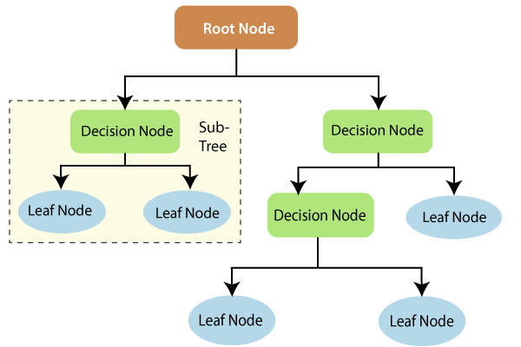

Information theory can provide more information on how decision trees work. Entropy and information gain are the building blocks of decision trees. An overview of these fundamental concepts will improve our understanding of how decision trees are built.

Entropy is a metric for calculating uncertainty. Information gain is a measure of how uncertainty in the target variable is reduced, given a set of independent variables.

The information gain concept involves using independent variables (features) to gain information about a target variable (class). The entropy of the target variable (Y) and the [conditional entropy](https://en.wikipedia.org/wiki/Conditional_entropy) of Y (given X) are used to estimate the information gain. In this case, the conditional entropy is subtracted from the entropy of Y.

Information gain is used in the training of decision trees. It helps in reducing uncertainty in these trees. A high information gain means that a high degree of uncertainty (information entropy) has been removed. Entropy and information gain are important in splitting branches, which is an important activity in the construction of decision trees.

Let’s take a simple example of how a decision tree works. Suppose we want to predict if a customer will purchase a mobile phone or not. The features of the phone form the basis of his decision. This analysis can be presented in a decision tree diagram.

The root node and decision nodes of the decision represent the features of the phone mentioned above. The leaf node represents the final output, either *buying* or *not buying*. The main features that determine the choice include the price, internal storage, and Random Access Memory (RAM). The decision tree will appear as follows.

